**username:password**

grizzlybear:t05luo

fancybear:gwerty

cindybear:craftpw

bigbear:office  
yogibear:00399032  
mamabear:23742374  
fozziebear:iseesun  
booboobear:P@ssw0rd

barneybear:stonks

chicagobear:cmw880

**Description:**

|  |  |  |
| --- | --- | --- |
| **username:password** | **Hash type** | **wordlist** |
| grizzlybear:t05luo | Md5 | [xato-net-10-million-passwords-1000000.txt](https://github.com/danielmiessler/SecLists/blob/master/Passwords/xato-net-10-million-passwords-1000000.txt) |
| fancybear:gwerty  cindybear:craftpw | Md5 | [xato-net-10-million-passwords.txt](https://github.com/danielmiessler/SecLists/blob/master/Passwords/xato-net-10-million-passwords.txt) |
| barneybear:stonks  chicagobear:cmw880 | Md5 | No word list |
| bigbear:office | Sha512 | s |
| yogibear:00399032 mamabear:23742374 fozziebear:iseesun booboobear:P@ssw0rd | NTLM | https://crackstation.net/ |

**List:**   
/Users/murtuzasayeed/SecLists-master/Passwords  
crackme-spring2021.txt

[2020-200_most_used_passwords.txt](https://github.com/danielmiessler/SecLists/blob/master/Passwords/2020-200_most_used_passwords.txt)

[Keyboard-Combinations.txt](https://github.com/danielmiessler/SecLists/blob/master/Passwords/Keyboard-Combinations.txt)

[Most-Popular-Letter-Passes.txt](https://github.com/danielmiessler/SecLists/blob/master/Passwords/Most-Popular-Letter-Passes.txt)

[PHP-Magic-Hashes.txt](https://github.com/danielmiessler/SecLists/blob/master/Passwords/PHP-Magic-Hashes.txt)

[SCRABBLE-hackerhouse.tgz](https://github.com/danielmiessler/SecLists/blob/master/Passwords/SCRABBLE-hackerhouse.tgz)

[UserPassCombo-Jay.txt](https://github.com/danielmiessler/SecLists/blob/master/Passwords/UserPassCombo-Jay.txt)

[bt4-password.txt](https://github.com/danielmiessler/SecLists/blob/master/Passwords/bt4-password.txt)

[cirt-default-passwords.txt](https://github.com/danielmiessler/SecLists/blob/master/Passwords/cirt-default-passwords.txt)

[clarkson-university-82.txt](https://github.com/danielmiessler/SecLists/blob/master/Passwords/clarkson-university-82.txt)

[darkc0de.txt](https://github.com/danielmiessler/SecLists/blob/master/Passwords/darkc0de.txt)

[darkweb2017-top10.txt](https://github.com/danielmiessler/SecLists/blob/master/Passwords/darkweb2017-top10.txt)

[darkweb2017-top100.txt](https://github.com/danielmiessler/SecLists/blob/master/Passwords/darkweb2017-top100.txt)

[darkweb2017-top1000.txt](https://github.com/danielmiessler/SecLists/blob/master/Passwords/darkweb2017-top1000.txt)

[darkweb2017-top10000.txt](https://github.com/danielmiessler/SecLists/blob/master/Passwords/darkweb2017-top10000.txt)

[der-postillon.txt](https://github.com/danielmiessler/SecLists/blob/master/Passwords/der-postillon.txt)

[dutch_common_wordlist.txt](https://github.com/danielmiessler/SecLists/blob/master/Passwords/dutch_common_wordlist.txt)

[dutch_passwordlist.txt](https://github.com/danielmiessler/SecLists/blob/master/Passwords/dutch_passwordlist.txt)

[german_misc.txt](https://github.com/danielmiessler/SecLists/blob/master/Passwords/german_misc.txt)

[mssql-passwords-nansh0u-guardicore.txt](https://github.com/danielmiessler/SecLists/blob/master/Passwords/mssql-passwords-nansh0u-guardicore.txt)

[openwall.net-all.txt](https://github.com/danielmiessler/SecLists/blob/master/Passwords/openwall.net-all.txt)

[probable-v2-top12000.txt](https://github.com/danielmiessler/SecLists/blob/master/Passwords/probable-v2-top12000.txt)

[probable-v2-top1575.txt](https://github.com/danielmiessler/SecLists/blob/master/Passwords/probable-v2-top1575.txt)

[probable-v2-top207.txt](https://github.com/danielmiessler/SecLists/blob/master/Passwords/probable-v2-top207.txt)

[richelieu-french-top20000.txt](https://github.com/danielmiessler/SecLists/blob/master/Passwords/richelieu-french-top20000.txt)

[richelieu-french-top5000.txt](https://github.com/danielmiessler/SecLists/blob/master/Passwords/richelieu-french-top5000.txt)

[stupid-ones-in-production.txt](https://github.com/danielmiessler/SecLists/blob/master/Passwords/stupid-ones-in-production.txt)

[twitter-banned.txt](https://github.com/danielmiessler/SecLists/blob/master/Passwords/twitter-banned.txt)

[unkown-azul.txt](https://github.com/danielmiessler/SecLists/blob/master/Passwords/unkown-azul.txt)

[url-to-download-passwords.md](https://github.com/danielmiessler/SecLists/blob/master/Passwords/url-to-download-passwords.md)

[xato-net-10-million-passwords-10.txt](https://github.com/danielmiessler/SecLists/blob/master/Passwords/xato-net-10-million-passwords-10.txt)

[xato-net-10-million-passwords-100.txt](https://github.com/danielmiessler/SecLists/blob/master/Passwords/xato-net-10-million-passwords-100.txt)

[xato-net-10-million-passwords-1000.txt](https://github.com/danielmiessler/SecLists/blob/master/Passwords/xato-net-10-million-passwords-1000.txt)

[xato-net-10-million-passwords-10000.txt](https://github.com/danielmiessler/SecLists/blob/master/Passwords/xato-net-10-million-passwords-10000.txt)

[xato-net-10-million-passwords-100000.txt](https://github.com/danielmiessler/SecLists/blob/master/Passwords/xato-net-10-million-passwords-100000.txt)

[xato-net-10-million-passwords-1000000.txt](https://github.com/danielmiessler/SecLists/blob/master/Passwords/xato-net-10-million-passwords-1000000.txt)

[xato-net-10-million-passwords-dup.txt](https://github.com/danielmiessler/SecLists/blob/master/Passwords/xato-net-10-million-passwords-dup.txt)

[xato-net-10-million-passwords.txt](https://github.com/danielmiessler/SecLists/blob/master/Passwords/xato-net-10-million-passwords.txt)

[**BiblePass**](https://github.com/danielmiessler/SecLists/tree/master/Passwords/BiblePass)[BiblePass_part01.txt](https://github.com/danielmiessler/SecLists/blob/master/Passwords/BiblePass/BiblePass_part01.txt)

[BiblePass_part02.txt](https://github.com/danielmiessler/SecLists/blob/master/Passwords/BiblePass/BiblePass_part01.txt)

[BiblePass_part03.txt](https://github.com/danielmiessler/SecLists/blob/master/Passwords/BiblePass/BiblePass_part01.txt)

[BiblePass_part04.txt](https://github.com/danielmiessler/SecLists/blob/master/Passwords/BiblePass/BiblePass_part01.txt)

[BiblePass_part05.txt](https://github.com/danielmiessler/SecLists/blob/master/Passwords/BiblePass/BiblePass_part01.txt)

[BiblePass_part06.txt](https://github.com/danielmiessler/SecLists/blob/master/Passwords/BiblePass/BiblePass_part01.txt)

[BiblePass_part07.txt](https://github.com/danielmiessler/SecLists/blob/master/Passwords/BiblePass/BiblePass_part01.txt)

[BiblePass_part08.txt](https://github.com/danielmiessler/SecLists/blob/master/Passwords/BiblePass/BiblePass_part01.txt)

[BiblePass_part09.txt](https://github.com/danielmiessler/SecLists/blob/master/Passwords/BiblePass/BiblePass_part01.txt)

[BiblePass_part10.txt](https://github.com/danielmiessler/SecLists/blob/master/Passwords/BiblePass/BiblePass_part01.txt)

[BiblePass_part11.txt](https://github.com/danielmiessler/SecLists/blob/master/Passwords/BiblePass/BiblePass_part01.txt)

[BiblePass_part12.txt](https://github.com/danielmiessler/SecLists/blob/master/Passwords/BiblePass/BiblePass_part01.txt)  
[BiblePass_part13.txt](https://github.com/danielmiessler/SecLists/blob/master/Passwords/BiblePass/BiblePass_part01.txt)  
[BiblePass_part14.txt](https://github.com/danielmiessler/SecLists/blob/master/Passwords/BiblePass/BiblePass_part01.txt)  
[BiblePass_part15.txt](https://github.com/danielmiessler/SecLists/blob/master/Passwords/BiblePass/BiblePass_part01.txt)  
[BiblePass_part16.txt](https://github.com/danielmiessler/SecLists/blob/master/Passwords/BiblePass/BiblePass_part01.txt)  
[BiblePass_part17.txt](https://github.com/danielmiessler/SecLists/blob/master/Passwords/BiblePass/BiblePass_part01.txt)

[**Common-Credentials**](https://github.com/danielmiessler/SecLists/tree/master/Passwords/Common-Credentials)

[10-million-password-list-top-100.txt](https://github.com/danielmiessler/SecLists/blob/master/Passwords/Common-Credentials/10-million-password-list-top-100.txt)

[10-million-password-list-top-1000.txt](https://github.com/danielmiessler/SecLists/blob/master/Passwords/Common-Credentials/10-million-password-list-top-1000.txt)

[10-million-password-list-top-10000.txt](https://github.com/danielmiessler/SecLists/blob/master/Passwords/Common-Credentials/10-million-password-list-top-10000.txt)

[10-million-password-list-top-100000.txt](https://github.com/danielmiessler/SecLists/blob/master/Passwords/Common-Credentials/10-million-password-list-top-100000.txt)

[10-million-password-list-top-1000000.txt](https://github.com/danielmiessler/SecLists/blob/master/Passwords/Common-Credentials/10-million-password-list-top-1000000.txt)

[10-million-password-list-top-500.txt](https://github.com/danielmiessler/SecLists/blob/master/Passwords/Common-Credentials/10-million-password-list-top-500.txt)

[100k-most-used-passwords-NCSC.txt](https://github.com/danielmiessler/SecLists/blob/master/Passwords/Common-Credentials/100k-most-used-passwords-NCSC.txt)

[10k-most-common.txt](https://github.com/danielmiessler/SecLists/blob/master/Passwords/Common-Credentials/10k-most-common.txt)

[500-worst-passwords.txt](https://github.com/danielmiessler/SecLists/blob/master/Passwords/Common-Credentials/500-worst-passwords.txt)

[SplashData-2014.txt](https://github.com/danielmiessler/SecLists/blob/master/Passwords/Common-Credentials/SplashData-2014.txt)

[SplashData-2015-1.txt](https://github.com/danielmiessler/SecLists/blob/master/Passwords/Common-Credentials/SplashData-2015-1.txt)

[SplashData-2015-2.txt](https://github.com/danielmiessler/SecLists/blob/master/Passwords/Common-Credentials/SplashData-2015-2.txt)

[best1050.txt](https://github.com/danielmiessler/SecLists/blob/master/Passwords/Common-Credentials/best1050.txt)

[best110.txt](https://github.com/danielmiessler/SecLists/blob/master/Passwords/Common-Credentials/best110.txt)

[best15.txt](https://github.com/danielmiessler/SecLists/blob/master/Passwords/Common-Credentials/best15.txt)

[common-passwords-win.txt](https://github.com/danielmiessler/SecLists/blob/master/Passwords/Common-Credentials/common-passwords-win.txt)

[four-digit-pin-codes-sorted-by-frequency-withcount.csv](https://github.com/danielmiessler/SecLists/blob/master/Passwords/Common-Credentials/four-digit-pin-codes-sorted-by-frequency-withcount.csv)

[medical-devices.txt](https://github.com/danielmiessler/SecLists/blob/master/Passwords/Common-Credentials/medical-devices.txt)

[top-20-common-SSH-passwords.txt](https://github.com/danielmiessler/SecLists/blob/master/Passwords/Common-Credentials/top-20-common-SSH-passwords.txt)

[top-passwords-shortlist.txt](https://github.com/danielmiessler/SecLists/blob/master/Passwords/Common-Credentials/top-passwords-shortlist.txt)

[worst-passwords-2017-top100-slashdata.txt](https://github.com/danielmiessler/SecLists/blob/master/Passwords/Common-Credentials/worst-passwords-2017-top100-slashdata.txt)

[**Cracked-Hashes**](https://github.com/danielmiessler/SecLists/tree/master/Passwords/Cracked-Hashes)[milw0rm-dictionary.txt](https://github.com/danielmiessler/SecLists/blob/master/Passwords/Cracked-Hashes/milw0rm-dictionary.txt)

[**Default-Credentials**](https://github.com/danielmiessler/SecLists/tree/master/Passwords/Default-Credentials)

[db2-betterdefaultpasslist.txt](https://github.com/danielmiessler/SecLists/blob/master/Passwords/Default-Credentials/db2-betterdefaultpasslist.txt)

[default-passwords.csv](https://github.com/danielmiessler/SecLists/blob/master/Passwords/Default-Credentials/default-passwords.csv)

[ftp-betterdefaultpasslist.txt](https://github.com/danielmiessler/SecLists/blob/master/Passwords/Default-Credentials/ftp-betterdefaultpasslist.txt)

[mssql-betterdefaultpasslist.txt](https://github.com/danielmiessler/SecLists/blob/master/Passwords/Default-Credentials/mssql-betterdefaultpasslist.txt)

[mysql-betterdefaultpasslist.txt](https://github.com/danielmiessler/SecLists/blob/master/Passwords/Default-Credentials/mysql-betterdefaultpasslist.txt)

[oracle-betterdefaultpasslist.txt](https://github.com/danielmiessler/SecLists/blob/master/Passwords/Default-Credentials/oracle-betterdefaultpasslist.txt)

[oracle-ebs-passwordlist.txt](https://github.com/danielmiessler/SecLists/blob/master/Passwords/Default-Credentials/oracle-ebs-passwordlist.txt)

[oracle-ebs-userlist.txt](https://github.com/danielmiessler/SecLists/blob/master/Passwords/Default-Credentials/oracle-ebs-userlist.txt)

[postgres-betterdefaultpasslist.txt](https://github.com/danielmiessler/SecLists/blob/master/Passwords/Default-Credentials/postgres-betterdefaultpasslist.txt)

[scada-pass.csv](https://github.com/danielmiessler/SecLists/blob/master/Passwords/Default-Credentials/scada-pass.csv)

[ssh-betterdefaultpasslist.txt](https://github.com/danielmiessler/SecLists/blob/master/Passwords/Default-Credentials/ssh-betterdefaultpasslist.txt)

[telnet-betterdefaultpasslist.txt](https://github.com/danielmiessler/SecLists/blob/master/Passwords/Default-Credentials/telnet-betterdefaultpasslist.txt)

[telnet-phenoelit.txt](https://github.com/danielmiessler/SecLists/blob/master/Passwords/Default-Credentials/telnet-phenoelit.txt)

[tomcat-betterdefaultpasslist.txt](https://github.com/danielmiessler/SecLists/blob/master/Passwords/Default-Credentials/tomcat-betterdefaultpasslist.txt)

[vnc-betterdefaultpasslist.txt](https://github.com/danielmiessler/SecLists/blob/master/Passwords/Default-Credentials/vnc-betterdefaultpasslist.txt)

[windows-betterdefaultpasslist.txt](https://github.com/danielmiessler/SecLists/blob/master/Passwords/Default-Credentials/windows-betterdefaultpasslist.txt)

[**Honeypot-Captures**](https://github.com/danielmiessler/SecLists/tree/master/Passwords/Honeypot-Captures)[Sucuri-Top-Wordpress-Passwords.txt](https://github.com/danielmiessler/SecLists/blob/master/Passwords/Honeypot-Captures/Sucuri-Top-Wordpress-Passwords.txt)

[multiplesources-passwords-fabian-fingerle.de.txt](https://github.com/danielmiessler/SecLists/blob/master/Passwords/Honeypot-Captures/multiplesources-passwords-fabian-fingerle.de.txt)

[python-heralding-sep2019.txt](https://github.com/danielmiessler/SecLists/blob/master/Passwords/Honeypot-Captures/python-heralding-sep2019.txt)

[wordpress-attacks-july2014.txt](https://github.com/danielmiessler/SecLists/blob/master/Passwords/Honeypot-Captures/wordpress-attacks-july2014.txt)

[**Leaked-Databases**](https://github.com/danielmiessler/SecLists/tree/master/Passwords/Leaked-Databases)[000webhost.txt](https://github.com/danielmiessler/SecLists/blob/master/Passwords/Leaked-Databases/000webhost.txt)

[Ashley-Madison.txt](https://github.com/danielmiessler/SecLists/blob/master/Passwords/Leaked-Databases/Ashley-Madison.txt)

[Lizard-Squad.txt](https://github.com/danielmiessler/SecLists/blob/master/Passwords/Leaked-Databases/Lizard-Squad.txt)

[NordVPN.txt](https://github.com/danielmiessler/SecLists/blob/master/Passwords/Leaked-Databases/NordVPN.txt)

[adobe100.txt](https://github.com/danielmiessler/SecLists/blob/master/Passwords/Leaked-Databases/adobe100.txt)

[alleged-gmail-passwords.txt](https://github.com/danielmiessler/SecLists/blob/master/Passwords/Leaked-Databases/alleged-gmail-passwords.txt)

[bible-withcount.txt](https://github.com/danielmiessler/SecLists/blob/master/Passwords/Leaked-Databases/bible-withcount.txt)

[bible.txt](https://github.com/danielmiessler/SecLists/blob/master/Passwords/Leaked-Databases/bible.txt)

[carders.cc.txt](https://github.com/danielmiessler/SecLists/blob/master/Passwords/Leaked-Databases/carders.cc.txt)

[elitehacker-withcount.txt](https://github.com/danielmiessler/SecLists/blob/master/Passwords/Leaked-Databases/elitehacker-withcount.txt)

[elitehacker.txt](https://github.com/danielmiessler/SecLists/blob/master/Passwords/Leaked-Databases/elitehacker.txt)

[faithwriters-withcount.txt](https://github.com/danielmiessler/SecLists/blob/master/Passwords/Leaked-Databases/faithwriters-withcount.txt)

[faithwriters.txt](https://github.com/danielmiessler/SecLists/blob/master/Passwords/Leaked-Databases/faithwriters.txt)

[hak5-withcount.txt](https://github.com/danielmiessler/SecLists/blob/master/Passwords/Leaked-Databases/hak5-withcount.txt)

[hak5.txt](https://github.com/danielmiessler/SecLists/blob/master/Passwords/Leaked-Databases/hak5.txt)

[honeynet-withcount.txt](https://github.com/danielmiessler/SecLists/blob/master/Passwords/Leaked-Databases/honeynet-withcount.txt)

[honeynet.txt](https://github.com/danielmiessler/SecLists/blob/master/Passwords/Leaked-Databases/honeynet.txt)

[honeynet2.txt](https://github.com/danielmiessler/SecLists/blob/master/Passwords/Leaked-Databases/honeynet2.txt)

[hotmail.txt](https://github.com/danielmiessler/SecLists/blob/master/Passwords/Leaked-Databases/hotmail.txt)

[izmy.txt](https://github.com/danielmiessler/SecLists/blob/master/Passwords/Leaked-Databases/izmy.txt)

[md5decryptor-uk.txt](https://github.com/danielmiessler/SecLists/blob/master/Passwords/Leaked-Databases/md5decryptor-uk.txt)

[muslimMatch-withcount.txt](https://github.com/danielmiessler/SecLists/blob/master/Passwords/Leaked-Databases/muslimMatch-withcount.txt)

[muslimMatch.txt](https://github.com/danielmiessler/SecLists/blob/master/Passwords/Leaked-Databases/muslimMatch.txt)

[myspace-withcount.txt](https://github.com/danielmiessler/SecLists/blob/master/Passwords/Leaked-Databases/myspace-withcount.txt)

[myspace.txt](https://github.com/danielmiessler/SecLists/blob/master/Passwords/Leaked-Databases/myspace.txt)

[phpbb-cleaned-up.txt](https://github.com/danielmiessler/SecLists/blob/master/Passwords/Leaked-Databases/phpbb-cleaned-up.txt)

[phpbb-withcount.txt](https://github.com/danielmiessler/SecLists/blob/master/Passwords/Leaked-Databases/phpbb-withcount.txt)

[phpbb.txt](https://github.com/danielmiessler/SecLists/blob/master/Passwords/Leaked-Databases/phpbb.txt)

[porn-unknown-withcount.txt](https://github.com/danielmiessler/SecLists/blob/master/Passwords/Leaked-Databases/porn-unknown-withcount.txt)

[porn-unknown.txt](https://github.com/danielmiessler/SecLists/blob/master/Passwords/Leaked-Databases/porn-unknown.txt)

[rockyou-05.txt](https://github.com/danielmiessler/SecLists/blob/master/Passwords/Leaked-Databases/rockyou-05.txt)

[rockyou-10.txt](https://github.com/danielmiessler/SecLists/blob/master/Passwords/Leaked-Databases/rockyou-10.txt)

[rockyou-15.txt](https://github.com/danielmiessler/SecLists/blob/master/Passwords/Leaked-Databases/rockyou-15.txt)

[rockyou-20.txt](https://github.com/danielmiessler/SecLists/blob/master/Passwords/Leaked-Databases/rockyou-20.txt)

[rockyou-25.txt](https://github.com/danielmiessler/SecLists/blob/master/Passwords/Leaked-Databases/rockyou-25.txt)

[rockyou-30.txt](https://github.com/danielmiessler/SecLists/blob/master/Passwords/Leaked-Databases/rockyou-30.txt)

[rockyou-35.txt](https://github.com/danielmiessler/SecLists/blob/master/Passwords/Leaked-Databases/rockyou-35.txt)

[rockyou-40.txt](https://github.com/danielmiessler/SecLists/blob/master/Passwords/Leaked-Databases/rockyou-40.txt)

[rockyou-45.txt](https://github.com/danielmiessler/SecLists/blob/master/Passwords/Leaked-Databases/rockyou-45.txt)

[rockyou-50.txt](https://github.com/danielmiessler/SecLists/blob/master/Passwords/Leaked-Databases/rockyou-50.txt)

[rockyou-55.txt](https://github.com/danielmiessler/SecLists/blob/master/Passwords/Leaked-Databases/rockyou-55.txt)

[rockyou-60.txt](https://github.com/danielmiessler/SecLists/blob/master/Passwords/Leaked-Databases/rockyou-60.txt)

[rockyou-65.txt](https://github.com/danielmiessler/SecLists/blob/master/Passwords/Leaked-Databases/rockyou-65.txt)

[rockyou-70.txt](https://github.com/danielmiessler/SecLists/blob/master/Passwords/Leaked-Databases/rockyou-70.txt)

[rockyou-75.txt](https://github.com/danielmiessler/SecLists/blob/master/Passwords/Leaked-Databases/rockyou-75.txt)

[rockyou-withcount.txt.tar.gz](https://github.com/danielmiessler/SecLists/blob/master/Passwords/Leaked-Databases/rockyou-withcount.txt.tar.gz)

[y](https://github.com/danielmiessler/SecLists/blob/master/Passwords/Leaked-Databases/rockyou.txt.tar.gz)

[singles.org-withcount.txt](https://github.com/danielmiessler/SecLists/blob/master/Passwords/Leaked-Databases/singles.org-withcount.txt)

[singles.org.txt](https://github.com/danielmiessler/SecLists/blob/master/Passwords/Leaked-Databases/singles.org.txt)

[tuscl.txt](https://github.com/danielmiessler/SecLists/blob/master/Passwords/Leaked-Databases/tuscl.txt)

[youporn2012-raw.txt](https://github.com/danielmiessler/SecLists/blob/master/Passwords/Leaked-Databases/youporn2012-raw.txt)

[youporn2012.txt](https://github.com/danielmiessler/SecLists/blob/master/Passwords/Leaked-Databases/youporn2012.txt)

[**Malware**](https://github.com/danielmiessler/SecLists/tree/master/Passwords/Malware)[conficker.txt](https://github.com/danielmiessler/SecLists/blob/master/Passwords/Malware/conficker.txt)

[mirai-botnet.txt](https://github.com/danielmiessler/SecLists/blob/master/Passwords/Malware/mirai-botnet.txt)

[**Permutations**](https://github.com/danielmiessler/SecLists/tree/master/Passwords/Permutations)[1337speak.txt](https://github.com/danielmiessler/SecLists/blob/master/Passwords/Permutations/1337speak.txt)

[korelogic-password.txt](https://github.com/danielmiessler/SecLists/blob/master/Passwords/Permutations/korelogic-password.txt)

[password-permutations.txt](https://github.com/danielmiessler/SecLists/blob/master/Passwords/Permutations/password-permutations.txt)

[**Software**](https://github.com/danielmiessler/SecLists/tree/master/Passwords/Software)[cain-and-abel.txt](https://github.com/danielmiessler/SecLists/blob/master/Passwords/Software/cain-and-abel.txt)

[john-the-ripper.txt](https://github.com/danielmiessler/SecLists/blob/master/Passwords/Software/john-the-ripper.txt)

**WiFi-WPA**

[probable-v2-wpa-top447.txt](https://github.com/danielmiessler/SecLists/blob/master/Passwords/WiFi-WPA/probable-v2-wpa-top447.txt)

[probable-v2-wpa-top4800.txt](https://github.com/danielmiessler/SecLists/blob/master/Passwords/WiFi-WPA/probable-v2-wpa-top4800.txt)

[probable-v2-wpa-top62.txt](https://github.com/danielmiessler/SecLists/blob/master/Passwords/WiFi-WPA/probable-v2-wpa-top62.txt)

**Snapshot:**grizzlybear:t05luo  
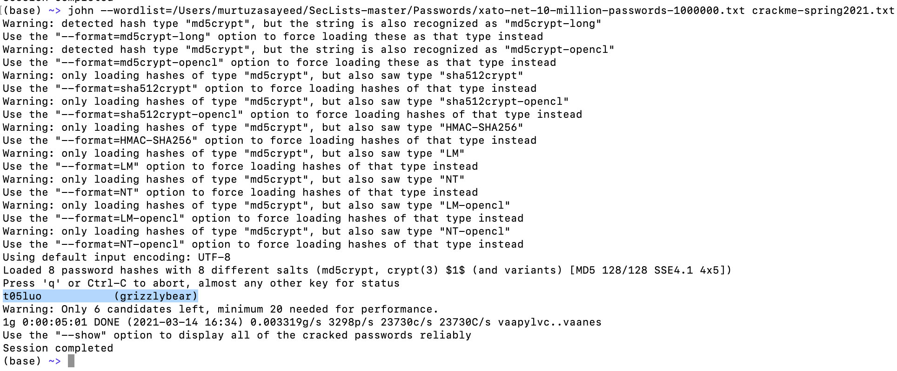

fancybear:gwerty

cindybear:craftpw

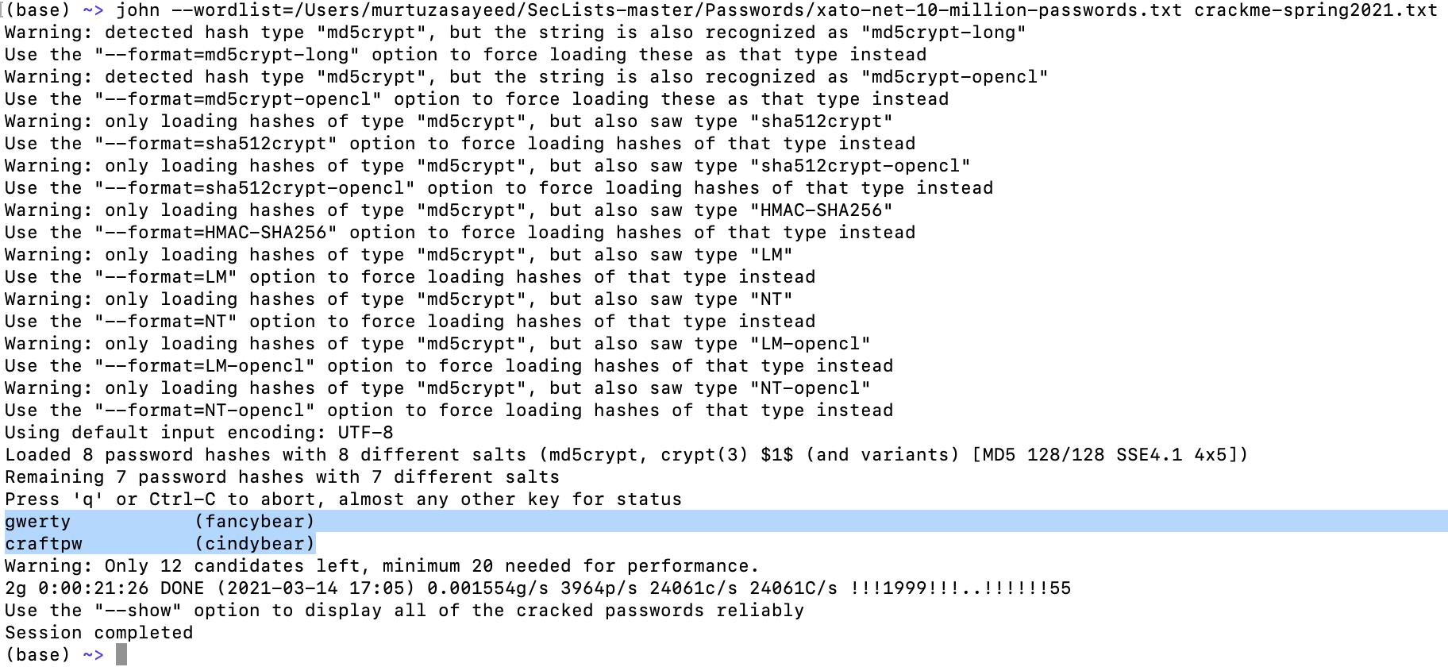

barneybear:stonks

chicagobear:cmw880

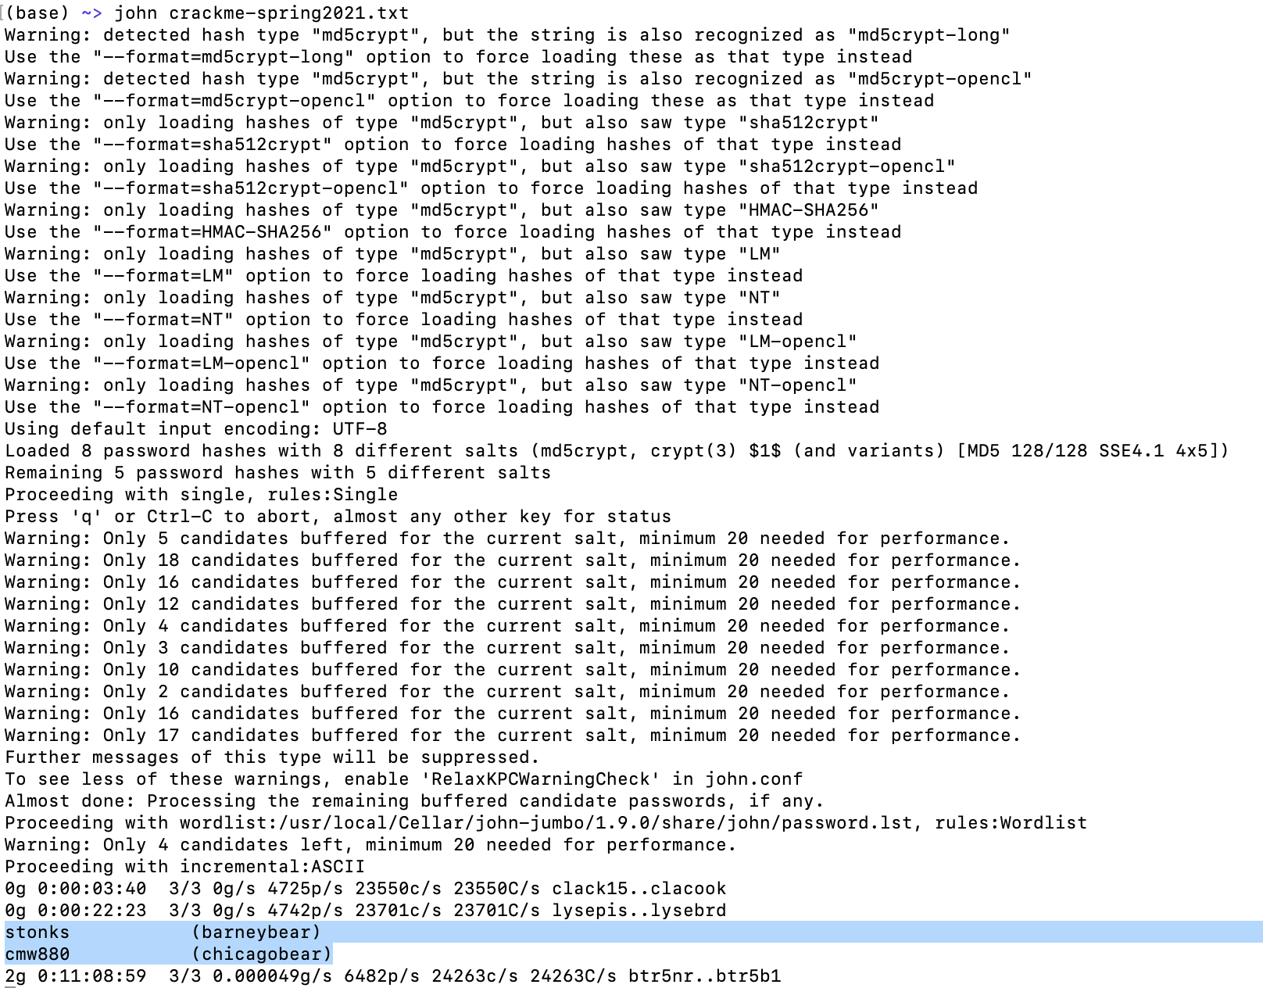

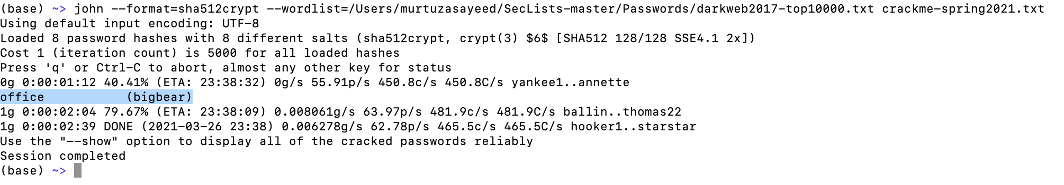

And which format? Did you run it with md5crypt sha512crypt, hmac, LM, NT etc?